 Procedure for tying the karate belt.
Using a karate belt, practice putting on and tying the knot correctly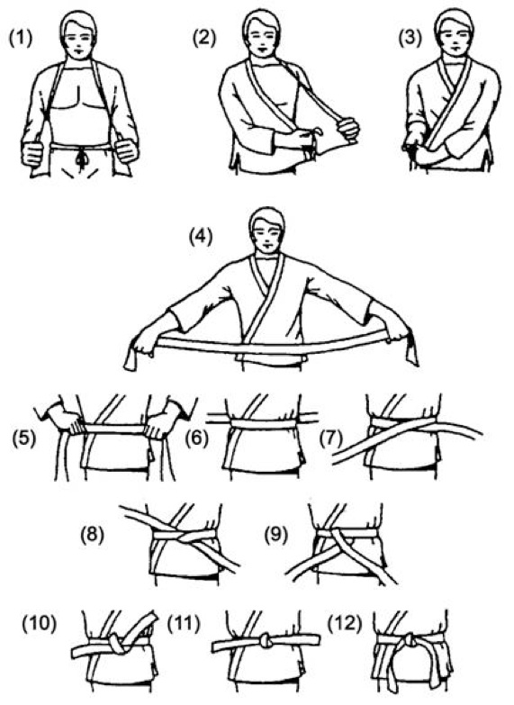

Step form of how to tie your belt properly.
Refer to picture guide on reverse side.
- Gi Top
- Right side of top inside left. Tie in a bow.
- Left side over top. Tie in a bow.
- Extend centre of belt over belly button.
- With centre of belt over your naval, wrap both sides behind then cross over at the back.
- Return both sides to your front mid section.
- Left side of belt cross over right.
- Left now comes up and under both parts belt.
- Right over left.
10. Bring right up and under left to form a knot.
11. Pull belt to tighten knot.
12. Must be balanced both sides equal.

Practice makes perfect!
Sensei Paul.

